VIETNAM
STATEACTION PLAN
TO REDUCE
CIVIL AVIATION
CO₂ EMISSIONS

2021-2024

Table of Contents
SECTION 1 BACKGROUND INFORMATION AND CONTACTS 4
1.1 Contact Information 4
1.2 Overview of Vietnam Civil Aviation 5
1.3 Air Transportation Market in Vietnam 5
1.4 Airlines 6
1.5 Airports 6
1.6 Air Traffic Management Infrastructure 7
SECTION 2 BASELINE AND EXPECTED RESULTS 9
Summary results 9
SECTION 3 MITIGATION MEASURES 19

ACRONYMS

ACI | Airports Council International
ACV | Airport Corporation of Vietnam
ANSP | Air navigation service provider
CAAV | Civil Aviation Authority of Vietnam
CAEP | Committee on Aviation Environmental Protection Civil Air Navigation Services Organization
CANSO | Civil Air Navigation Services Organization
CO₂ | Carbon dioxide
CO_{2e} | Carbon dioxide equivalent
GHG | Greenhouse gas
IATA | International Air Transport Association
ICAO | International Civil Aviation Organization
IFSET | Fuel Savings Estimation Tool
IPCC | Intergovernmental Panel on Climate Change
Kt | Kilotonne
MBM | Market-based measure
MoT | Ministry of Transport
PBN | Performance-based navigation
REDD | Reducing emissions from deforestation and forest degradation
RNP | Required navigation performance
RTK | Revenue tonne-kilometer
Tkm | Tonne-kilometer
UNDP | United Nations Development Programme
UNFCCC | United Nations Framework Convention on Climate Change
VATM | Vietnam Air Traffic Management Corporation

SECTION 1 BACKGROUND INFORMATION AND CONTACTS

Contact Information

Name of the Authority: Civil Aviation Administration of Vietnam

Point of contact: Vu Thi Thanh (M.Sc.)Deputy Director

Street address: 119 Nguyenson Str., Longbien Dist.,

City:Hanoi

Country: Vietnam

Telephone number: 84.4.38 729 792, +84.4.38 271 513 ext 8358

Fax: +84.4.38 721 933

E-mail address:thanhvt@caa.gov.vn

Overview of Vietnam Civil Aviation
Vietnam’s civil aviation industry is an important sector of the country’s economy. IATA has evaluated the domestic market as having high potential for continued growth. The sector has witnessed impressive development in three areas: air transportation, airport infrastructure, and air traffic management.
The Vietnam air transportation market has maintained fast growth at a doubledigit-rate for the last 5-year period. The route network of the nation’s airlines has been expanded in line with the directions described in the Decision numbered 21/QĐ-TTg by the Prime Minister, dated 8th, January 2009 approving the Development of a Master Plan for Air Transportation for the period to 2020 and orientation to 2030. The service quality has been improving constantly. Opening for private investment and equitization in the air transportation business has promoted and created positive conditions for private airlines, created motivation for competition in the domestic market, diversification of products and services, increased opportunities for the population to utilize air transport products and services, all contributing to the development of the market. The Policy of liberalization of air transport in accordance with the plan has encouraged international airlines to open routes to Vietnam, expanded business opportunities and accelerated the development of the market between Vietnam and the world, playing an important part in the market growth during the last period. The planning of new airports that can accept international flights creates positive conditions for social-economic development of the regions in line with the Government directions, and opens opportunities for tourism centers to connect with international destinations. The country has established three primary international gateways: Noi Bai, Da Nang, Tan Son Nhat. Other international airports have been developed to receive scheduled/unscheduled international flights of Vietnamese airlines and foreign carriers when needed in accordance with the tourism development plans of the Government.
The aircraft fleet has experience positive growth with delivery of new aircraft and modern technology. Priority has been on the expansion of the owned fleet contributing to the sustainable and efficient development of Vietnamese airlines.

Air Transportation Market in Vietnam
During the period 2009 – 2016, the air transportation market achieved high, continuous growth at an average annual rate of 17% for passengers and 14.4% for cargo. In 2016, the Vietnam’s total air transportation market was estimated at around 52.2 million passengers (an increase of 28.8% from 2015) and 902,107 tones of cargo (an increase of more than 13.8% from 2015).
There has been a balance in the growth of the international and domestic markets. The domestic market has caught up and surpassed the international in number of passengers carried. In 2009, the ratio of international/domestic passenger was 1.03. In 2014, the domestic market was estimated to achieve 17.7 million passengers and it was the first time the domestic market surpassed the international in absolute passenger numbers.
At present, there are 5 Vietnam-based carriers exploiting the market: Vietnam Airlines (VN), Jetstar Pacific (BL), VASCO, VietJet Air (VJ) and Hai Au. Amongst these BL and VJ are operating as low cost carriers (LCC). Vietnam Airlines, Jetstar Pacific and VietJet Air operate 56 international routes to 32 destinations in 17 countries and territories. In the domestic market these airlines operate 46 routes connecting Hanoi, Da Nang, Ho Chi Minh City with 17 local airports in a hub-and-spoke model and point-to-point countrywide.

Airlines
During the period 2009-2016, Vietnam’s airline fleet has grown rapidly in both quantity and quality. The quantity of aircraft has increased in all 3 groups: shortrange, medium range and long range. Up to 2016, Total of Vietnam’s airline fleet was 157 aircraft and the average age of the fleet was 5.1 years. The owned fleet had 59 units, and counted for 37.6% of the total fleet.

Airports
According to the airport network plan approved by the Prime Minister under Decision No. 21/QĐ-TTg, dated 8th, January 2009, during the period up to 2020 there will be 26 airports commissioned.
Currently, there are 21 civil aviation airports in operation. Among those there are 7 international airports and 14 domestic. Besides the three major international airports, Vietnam is commissioning or will soon commission new airports that are able to receive international flights in major cities and locations including: Hue
(Phu Bai airport), Nha Trang (Cam Ranh airport), Can Tho (Can Tho airport), Da Lat (Lien Khuong airport) and Phu Quoc (Phu Quoc airport).
Total throughput of the existing airport network is over 50 million passengers/year and almost 1 million tones of cargo/year.
Throughput achieved at Vietnam’s airport network during the period 2009- 2016was as follows:

Year | Take-off and landings | Passengers | Cargo (Tones)
2009 | 204,147 | 26,159,116 | 445,762
2010 | 244,288 | 31,507,846 | 583,560
2011 | 295,306 | 35,704,264 | 604,280
2012 | 308,990 | 37,532,267 | 648,995
2013 | 329,917 | 44,039,568 | 766,616
2014 | 370,450 | 50,527,820 | 905,398
2015 | 449,310 | 52.200.519 | 902.107
2016 | 558,504 | 63.017.277 | 964.644

0
500.000
1.000.000
1.500.000
2.000.000
2.500.000
2009
2010
2011
2012
2013
2014
2015
2016
Hànghóa
Hànhkhách
Cargo

Pax

Total passenger and cargo throughput during the 2009-2016 period.

Air Traffic Management Infrastructure
With oversight by the Vietnam Air Traffic Management Corporation, The ATM system is organized as follows:
- Operation and management of the two Flight Information Regions (FIRs), Ho Chi Minh and Hanoi, covering all the territorial airspace of Vietnam and the airspace above international waters assigned by ICAO to Vietnam for navigation with 25 domestic airways, 34 international airways, 3 approach areas: Noi Bai, Da Nang and Tan Son Nhat, 22 airport controlling areas and 3 ground controlling areas at Noi Bai, Da Nang, and Tan Son Nhat airports;
- Operation of more than 300 equipment systems (with issued Operation Certificates) with 4 primary radar and 7 secondary radar, point-to-point ground communication network (AFTN, on-duty telephone), ground-to-air communication network, navigation systems (ILS, VOD, DME, NDB and lighting signalization), aviation weather systems, aeronautical information systems, and the Search and Rescue equipment. Among those, VATM has invested and developed CNS services with advanced modern technology solutions, particularly:
+ Aeronautical Communication Service including two types: Aeronautical Mobile Service – AMS and Aeronautical Fixed Services – AFS;
+ Ground-air-communication providing communication between ground ATM officials and pilots.

Performance of ATM across all flights
Year | 2009 | 2010 2011 | 2012 2013
Flights managed | 312,038 | 359,505 420,660 | 457,172 502,765
Equivalent Km managed  (1000’s of km) | 411,365 | 474,510 568,976 | 648,445 703,564
Year |  | 2014 | 2015
Flights managed |  | 544,931 | 640,848
Equivalent Km managed  (1000’s of km) |  | 919,820,507 | 1,056,539,147

SECTION 2 BASELINE AND EXPECTED RESULTS
In order to understand the benefits that can be expected from the implementation of a basket of measures, it is useful to quantify both the historic fuel consumption and traffic, as well as to project into the future what would happen in the absence of the action plan.

Summary results
For Vietnam aviation the ICAO definition for international flights is applied:
International flight is a flight stage with one or both terminals in the territory of a state, other than the state in which the air carrier has its principal place of business i.e. Vietnam.
This includes flights where the departure or destination state is Vietnam and flights between states outside of Vietnam.
Historical data used for calculations has been collected and provided by CAAV. The structure and units of measurement of data align with ICAO form M including fuel consumption, RTKs for international flights and Total Services (revenue and non-revenue for International and Domestic).
The aggregated data covers a 6-year period from 2014-2019 and includes all airlines undertaking international operations that have been operating during the period. It is used to calculate the baseline.
Because of some doubts about the RTK data for 2020, this data is put aside for the moment. In any case, 2020 was an exceptional year because of the COVID-19 pandemic.

As per Document 9988, the formula for calculation of CO₂ as follow:
CO₂ Emission (tonnes) = Fuel Consumption (tones) x 3.16
Calculation of CO₂ Emission for period 2010-2014:
The following table summarises historical fuel consumption data, the CO₂ emissions and fuel efficiency (litres Fuel/RTK) for international flights for the period 2014-2019:

YEAR | Fuel Burn |  | RTK | FB/RTK |  | CO₂ Emission
 | litres | tonnes | thousand | litre/RTK | Kg/RTK | tonnes
2014 | 834 368 750 | 667495 | 2 037 607 | 0.41 | 0.33 | 2 109 284
2015 | 905 210 125 | 724168 | 2 226 282 | 0.41 | 0.33 | 2 288 371
2016 | 1 043 241 500 | 834593 | 2 960 593 | 0.35 | 0.28 | 2 637 315
2017 | 1 239 152 875 | 991322 | 3 313 297 | 0.37 | 0.30 | 3 132 578
2018 | 1 439 450 000 | 1151560 | 4 197 823 | 0.34 | 0.27 | 3 638 930
2019 | 1 650 647 061 | 1320518 | 4 737 504 | 0.35 | 0.28 | 4 172 836

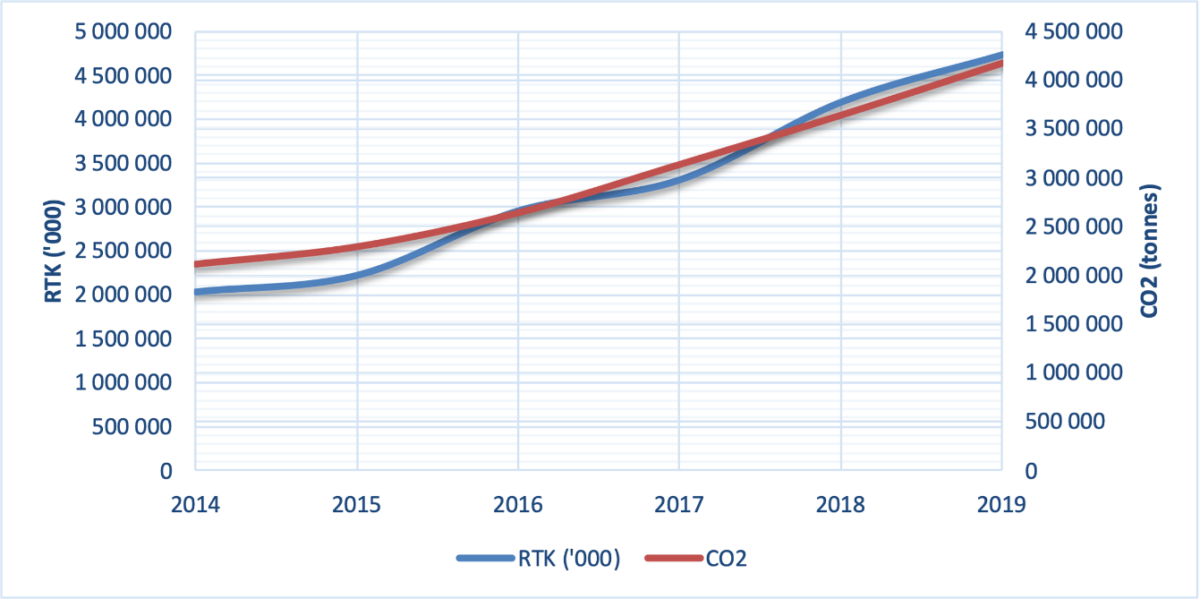
Figure 0-1 Historical RTK and CO2 Baseline

The above figure shows how historical CO2 emissions have grown based on historical RTK growth.

The observation can be made that C02 emissions have grown slightly less strongly compared to RTK growth over this period. This can be attributed to the improving efficiency of the fleet.

In order to develop this baseline and make a prediction of the “business as usual” (BAU) case, we need to make some forecasts about future RTK growth and also the fuel efficiency of the fleet in future.

Three future business as usual scenarios have been defined, taking into account the current situation which is still being impacted by the global coronavirus pandemic.

Some consensus about these future scenarios should be solicited from the airline operators.

Scenario 1: Historical and predicted baseline emissionsfor international flights from 2014 to 2030
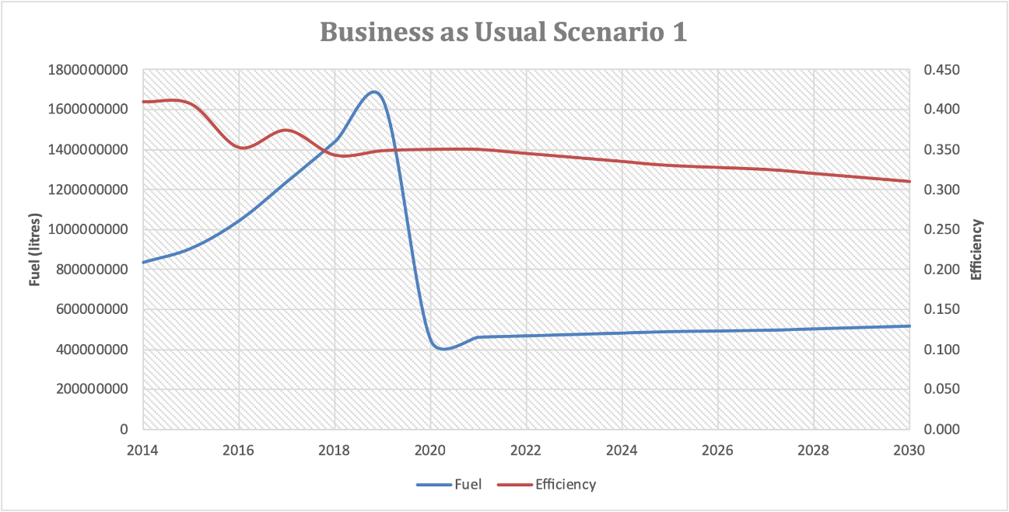
In this scenario, a very modest growth rate of 3% is applied tothe RTK of 2020.
The fuel efficiency is assumed to improve year on year by 0.005up to 2030 (by which time it is 0.31).
Total fuel consumption is around 515 million litres in 2030 which is less than a third of the1650 million litres used in 2109.

Year | RTK ('000) | RTK % change | Fuel Consumed (litres) | Year on year Fuel % change | (Calculated) Efficiency
2014 | 2 037 607 |  | 834 368 750 |  | 0.409
2015 | 2 226 282 | 9% | 905 210 125 | 8% | 0.407
2016 | 2 960 593 | 33% | 1 043 241 500 | 15% | 0.352
2017 | 3 313 297 | 12% | 1 239 152 875 | 19% | 0.374
2018 | 4 197 823 | 27% | 1 439 450 000 | 16% | 0.343
2019 | 4 737 504 | 13% | 1 650 647 061 | 15% | 0.348
2020 | 1 273 021 | -73% | 445 557 480 | -73% | 0.350
2021 | 1 311 212 | 3% | 458 924 205 | 3% | 0.350
2022 | 1 350 548 | 3% | 465 939 189 | 2% | 0.345
2023 | 1 391 065 | 3% | 472 962 040 | 2% | 0.340
2024 | 1 432 797 | 3% | 479 986 918 | 1% | 0.335
2025 | 1 475 781 | 3% | 487 007 622 | 1% | 0.330
2027 | 1 520 054 | 3% | 494 017 580 | 1% | 0.325
2028 | 1 565 656 | 3% | 501 009 829 | 1% | 0.320
2029 | 1 612 625 | 3% | 507 976 997 | 1% | 0.315
2030 | 1 661 004 | 3% | 514 911 286 | 1% | 0.310

Scenario 2: Historical and predicted baseline emissionsfor international flights from 2014 to 2030
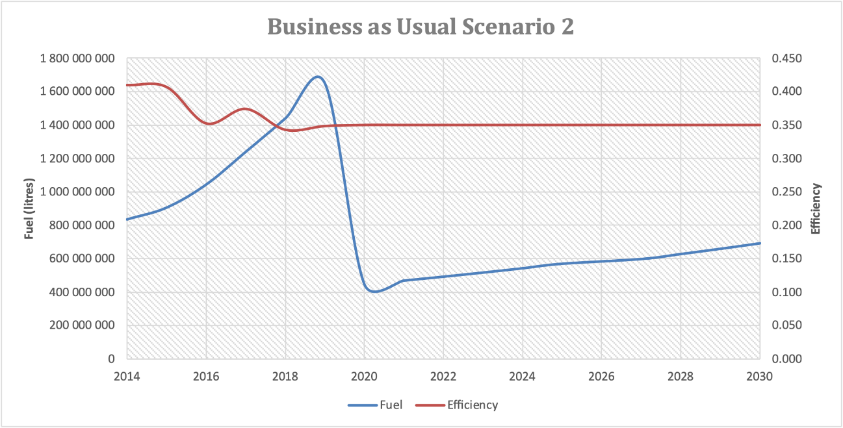
In this scenario, a more historically typical growth rate of 5% is applied to the RTK of 2020.
The fuel efficiency in this case is assumed to stay the same year on year at 0.35.
In this scenario, total fuel consumption in 2030 is just below700 million litres, still very much reduced compared to the 1650 million litres used in 2019.
Year | RTK ('000) | RTK % change | Fuel Consumed (litres) | Year on year Fuel % change | (Calculated) Efficiency
2014 | 2 037 607 |  | 834 368 750 |  | 0.409
2015 | 2 226 282 | 9% | 905 210 125 | 8% | 0.407
2016 | 2 960 593 | 33% | 1 043 241 500 | 15% | 0.352
2017 | 3 313 297 | 12% | 1 239 152 875 | 19% | 0.374
2018 | 4 197 823 | 27% | 1 439 450 000 | 16% | 0.343
2019 | 4 737 504 | 13% | 1 650 647 061 | 15% | 0.348
2020 | 1 273 021 | -73% | 445 557 480 | -73% | 0.350
2021 | 1 336 672 | 5% | 467 835 354 | 5% | 0.350
2022 | 1 403 506 | 5% | 491 227 122 | 5% | 0.350
2023 | 1 473 681 | 5% | 515 788 478 | 5% | 0.350
2024 | 1 547 365 | 5% | 541 577 902 | 5% | 0.350
2025 | 1 624 734 | 5% | 568 656 797 | 5% | 0.350
2027 | 1 705 970 | 5% | 597 089 637 | 5% | 0.350
2028 | 1 791 269 | 5% | 626 944 119 | 5% | 0.350
2029 | 1 880 832 | 5% | 658 291 325 | 5% | 0.350
2030 | 1 974 874 | 5% | 691 205 891 | 5% | 0.350

Scenario 3: Historical and predicted baseline emissionsfor international flights from 2014 to 2030
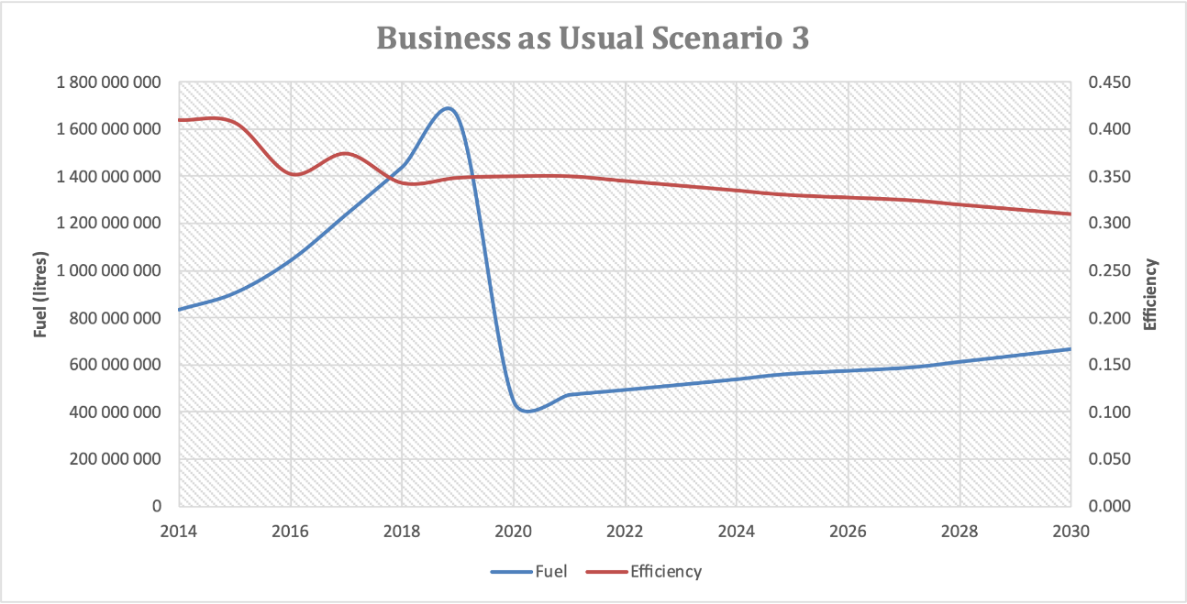
In this scenario, a more ambitious growth rate of 6% is applied to the RTK of 2020.
The fuel efficiency is assumed to improve year on year by 0.005 up to 2030 (by which time it is 0.31).
Total fuel consumption is around 666 million litres in 2030 which is around half the 1650 million litres used in 2019.
Year | RTK ('000) | RTK % change | Fuel Consumed (litres) | Year on year Fuel % change | (Calculated) Efficiency
2014 | 2 037 607 |  | 834 368 750 |  | 0.409
2015 | 2 226 282 | 9% | 905 210 125 | 8% | 0.407
2016 | 2 960 593 | 33% | 1 043 241 500 | 15% | 0.352
2017 | 3 313 297 | 12% | 1 239 152 875 | 19% | 0.374
2018 | 4 197 823 | 27% | 1 439 450 000 | 16% | 0.343
2019 | 4 737 504 | 13% | 1 650 647 061 | 15% | 0.348
2020 | 1 273 021 | -73% | 445 557 480 | -73% | 0.350
2021 | 1 349 403 | 6% | 472 290 929 | 6% | 0.350
2022 | 1 430 367 | 6% | 493 476 551 | 4% | 0.345
2023 | 1 516 189 | 6% | 515 504 200 | 4% | 0.340
2024 | 1 607 160 | 6% | 538 398 651 | 4% | 0.335
2025 | 1 703 590 | 6% | 562 184 621 | 4% | 0.330
2027 | 1 805 805 | 6% | 586 886 673 | 4% | 0.325
2028 | 1 914 153 | 6% | 612 529 106 | 4% | 0.320
2029 | 2 029 003 | 6% | 639 135 839 | 4% | 0.315
2030 | 2 150 743 | 6% | 666 730 275 | 4% | 0.310

Even with moderate to ambitious RTK growth rates, fuel consumption levels are not predicted to be anywhere near the levels previously seen in 2019.
It may well be, that in the next few years there will be a rapid reversal of the decline in RTK seen since the onset of the global pandemic.
If the airlines agree, we could also add a fourth scenario which adds a rapid growth initially to establish the same level of operations as around 2019, and then growing modestly from (say) 2025 (@5% per annum?)
Please discuss this with your airlines.

SECTION 3 MITIGATION MEASURES
a) a description of the action and an indication of its type (operational, technological, market-based, etc.);
b) time horizon (start date and date of full implementation);
c) anticipated change in fuel consumption and/or CO2 emissions;
d) economic cost and how it will be covered (domestic sources, regional funding, international assistance, etc.);
e) supplemental benefits for domestic sectors (mainly for domestic aviation, but others could also be reported, if appropriate);
f) reference to any relevant legislation;
g) identification of any barriers to implementation and any assistance needed; and
h) list of stakeholders involved.

After discussions with CAAV operational stakeholders, including all internationally operating airlines and airports, as well as the ANSP, a number of mitigation measures have been identified that could be expected to deliver CO2 savings in the next few years.
The review cycle of the SAP is normally taken to be around every 3 years, however in the circumstances of the global pandemic, and fact that 2020 has been elected as the starting point for this edition of the SAP, the period from 2020-2025 is proposed to be the scope for this action plan.
Progress and monitoring should be conducted annually.

A summary of the mitigation measures is presented here and details follow in the pages after:

 | Mitigation Measure | Basket of Measures Category | Stakeholder
1 | Single Engine Taxiing | Operational Improvements | Airlines
2 | New Airport Infrastructure | Operational Improvements | Airports
3 | Reduced route extensions | Operational Improvements | ANSP
4 | Taxi time reduction | Operational Improvements | Airports/Airlines
5 | Reduce on-stand APU usage | Operational Improvements | Airports/Airlines

Title | Single Engine Taxiing
Description | Increase the uptake of single engine taxiing by all Vietnamese Airlines
Category: | Operational Improvements
Measure: | % increase in single engine taxiing (SET) compared with 2019 measure
Action: | Need to establish level of SET in 2019 as a % of all operations.  Objective is to increase this % compared with 2019 metric.
Start Date | Jan 2020
Date of full implementation | Dec 2025
Implemented By: | All Vietnamese airlines (+airports?)
Economic cost
Currency
Reference to existing legislation
Legislation is proposed
Compliance | - voluntary  - mandatory  - N/A
Assistance needed | - finance  - technology  - technical support  - education  - research  - other
Amount of assistance needed
Currency for financial assistance
List of stakeholders involved | All airlines  Note: Van Don airport – looking to mandate & implement single engine Taxiing to and from the runway with all local Vietnamese airlines.

Title | New Airport Infrastructure
Description | Planned new infrastructure at some international airports in next 5 years will deliver high speed runway exits and new taxiways which will reduce the unimpeded taxi times
Category: | Operational Improvements
Measure: | % reduction in unimpeded (theoretical) taxi times for both taxi-in and taxi-out
Action: | Establish unimpeded taxi times for infrastructure in 2019. Compare with new times once new infrastructure is delivered
Start Date | tbc
Date of full implementation
Implemented By:
Economic cost | Can the cost be identified from the Master Plan?
Currency
Reference to existing legislation
Legislation is proposed
Compliance | - voluntary  - mandatory  - N/A
Assistance needed | - finance  - technology  - technical support  - education  - research  - other
Amount of assistance needed
Currency for financial assistance
List of stakeholders involved | List airports where this might be being already planned  Da Nang Airport - Airport infrastructure must be upgraded including more parallel taxiways and more rapid taxiways to shorten the time the aircraft moves to the apron and taxi for departure.

Title | Reduced route extensions
Description | VATM, as a lead member of ASEAN Strategic Planning Group, one of the objectives is to reduce route extensions on international routes but also review route inefficiencies in domestic airspace
Category: | Operational Improvements
Measure: | % route extension
Action: | Objective is to monitor and reduce the average route extension that Vietnamese airlines international flights are subjected to
Start Date | Jan 2020
Date of full implementation | Ongoing
Implemented By:
Economic cost
Currency
Reference to existing legislation
Legislation is proposed
Compliance | - voluntary  - mandatory  - N/A
Assistance needed | - finance  - technology  - technical support  - education  - research  - other
Amount of assistance needed
Currency for financial assistance
List of stakeholders involved | VATM will be proactive and lead this action.  Airlines will collaborate with VATM to share operational data that will help to monitor changes in performance.

Title | Taxi time reduction
Description | Implement performance measurement system at all international airports – based on goal of achieving optimum unimpeded taxi times (ie: without star-stops or delays)
Category: | Operational Improvements
Measure: | % above (based on minutes) unimpeded taxi time in and out (average)
Action: | Collaborative action between the airports/airlines and ANSP to reduce taxiing times – through improved coordination to minimize stop/starts during taxi in and out.
Start Date | Jan 2020
Date of full implementation | Ongoing
Implemented By: | Airports/ANSP/Airlines
Economic cost
Currency
Reference to existing legislation
Legislation is proposed
Compliance | - voluntary  - mandatory  - N/A
Assistance needed | - finance  - technology  - technical support  - education  - research  - other
Amount of assistance needed
Currency for financial assistance
List of stakeholders involved

Title | Reduce on-stand APU usage
Description | Where ground power and preconditioned air (PCA) is available on the stands this should be used rather than APU
Category: | Operational Improvements
Measure: | %reduction in aircraft using APU on stand
Action: | Establish the % of aircraft using APU on stand in 2019 (by airport and nationally) and monitor the increase in uptake of ground power and PCA
Start Date | Jan 2020
Date of full implementation | Ongoing
Implemented By:
Economic cost
Currency
Reference to existing legislation
Legislation is proposed
Compliance | - voluntary  - mandatory  - N/A
Assistance needed | - finance  - technology  - technical support  - education  - research  - other
Amount of assistance needed
Currency for financial assistance
List of stakeholders involved | Note: Van Don and Da Nang airports have mentioned this measure in their questionnaire feedback

